

**NATIONAL INSTITUTE OF TECHNOLOGY TIRUCHIRAPPALLI – 620 015**

**DEPARTMENT OF INSTRUMENTATION AND CONTROL ENGINEERING**

**Final Year Project - Second Review Report**

**Design and control of upper arm exoskeleton for arm motion assistance**

**110116009 - Arunagiri R**

**110116019 - Bharath Kumar R**

**110116041 - Keerthana J Guide: Dr. Periyasamy**

**Introduction:**

This research presents an idea on the design and control of an elbow exoskeleton for arm motion assistance. An efficient control algorithm is designed for the control of the arm action with respect to the input signal. The solid model of the exoskeleton is designed in a specific way to facilitate the ease of the user. The project paves way to a lot of potential applications in medical rehabilitation. The exoskeleton can be used as an assistive device for people with limb paralysis or history of stroke and can help them to perform their everyday activities with much ease. The product can also be used for easy and efficient arm movements of the user, allowing them to handle weights out of the scope of the user.

**Timeline and Objectives:**

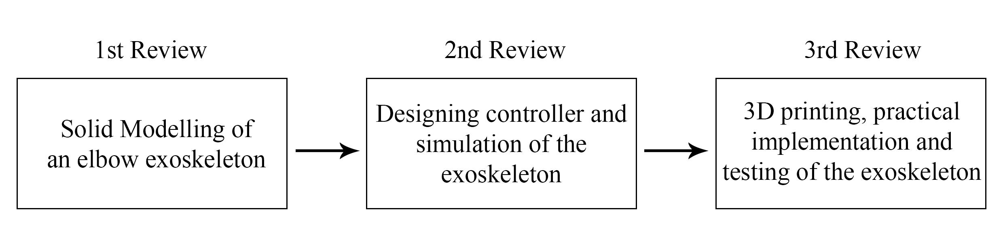

**Proposed Methodology:**

1. Mathematically model the upper limb exoskeleton in the MATLAB computing environment with appropriate model parameters.2. Design of CAD model of the upper limb exoskeleton in Adobe Fusion 360 solid modelling environment with the parameters decided during the mathematical modelling of the system.

3. Assemble all the CAD designs into the final structure of the upper limb exoskeleton with the help of the Adobe Fusion 360.

4. Design an impedance control algorithm to control the force at the end effector by controlling the actuators of the 2 degree of freedom exoskeleton.

5. Tune the impedance control algorithm to get the optimal output response from the system.

6. Import the CAD design of the system into the Gazebo - a real world physics simulator - and send the control signals to the joint actuators as simulated in MATLAB.

7. 3D print the CAD design and integrate it with the gazebo simulation model.

8. Test the 3D printed model in a real world environment for accuracy of the system.

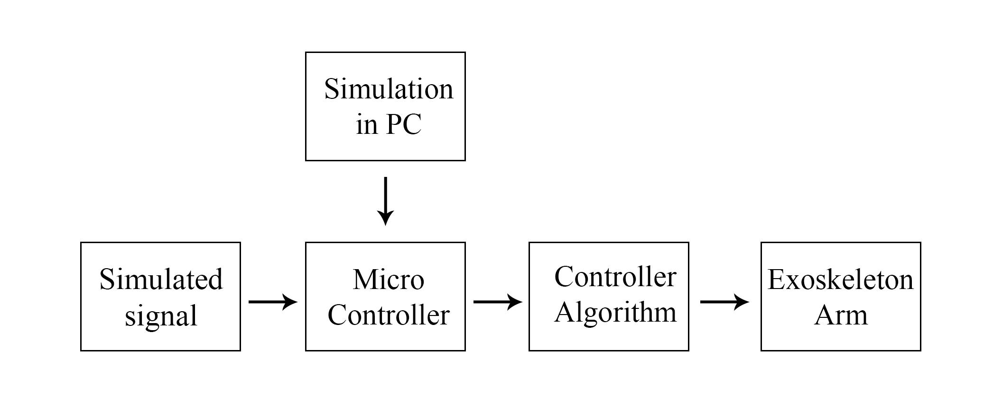

Block diagram of the project

**Progress:**

**Review I:**

A literature survey was conducted on various upper limb exoskeleton related research papers. Different designs and control algorithms used for the control of exoskeleton robots were studied extensively. The technical details of different exoskeletons that are being used in both research and industrial sectors were researched before coming up with a feasible design and control strategy.

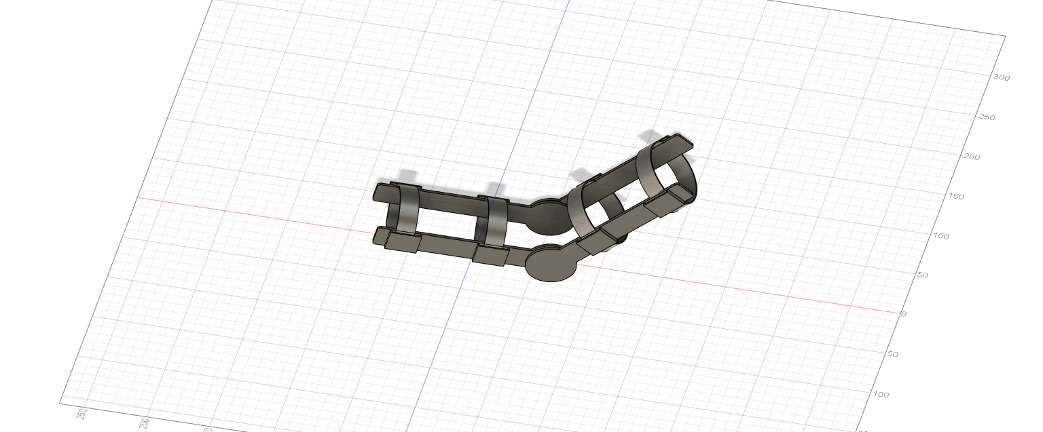

The design from review I

An exoskeleton arm is designed in Autodesk Fusion 360 according to the finalized design and the materials have been rendered as per the requirement. A simple elbow exoskeleton with 1 degree of freedom in the elbow joint is constructed in the CAD environment. The exoskeleton will have two rotary actuators on both sides to control the elbow angle as per the input command. The straps are made of elastic material to accommodate arms of various sizes.

**Review II:**

Mathematical Modelling:

A 4 degree of freedom arm with 3 degree of freedom in the shoulder and 1 degree of freedom in the elbow is mathematically using Denavit - Hartenberg parameters. Denavit -Hatenberg parameter technique is a formulation that can be used to find the forward kinematics equation in matrix form. The model gives output angles for input coordinates of the exoskeleton system.

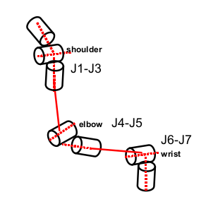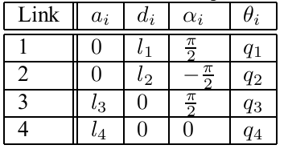

The design and DH parameters of the 4 DOF exoskeleton

Where,

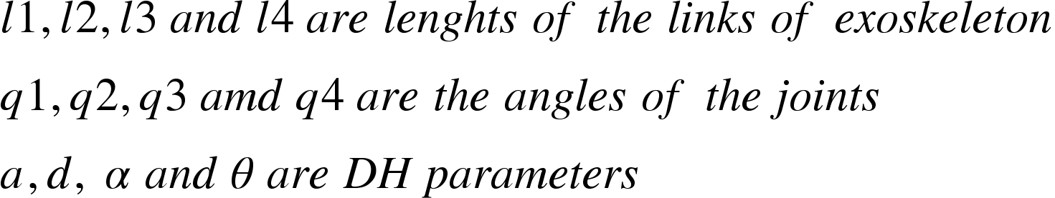

After the DH parameters are found, the parameters are inserted into the following matrices operations

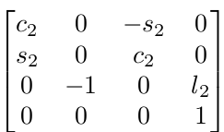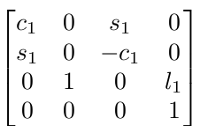

A1 = A2 =

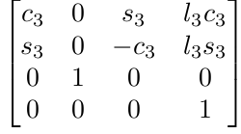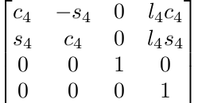

A3 = A4 =

The calculated matrices are then substituted into the following equation to get the coordinates of the end effector of the 4DOF exoskeleton

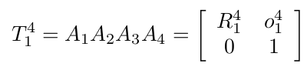



The CAD:

After the consideration of the multiple actuators for the elbow actuation and the absent support structure in the previous design, a new CAD of the exoskeleton is designed in the same platform. The new design has two arm links - lower arm and upper arm - connected together with a rotary joint. The upper arm link is in turn connected to the shoulder link with a rotary joint and the shoulder link is fixed to a support structure for better support. ABS is chosen as the filling material for the CAD.

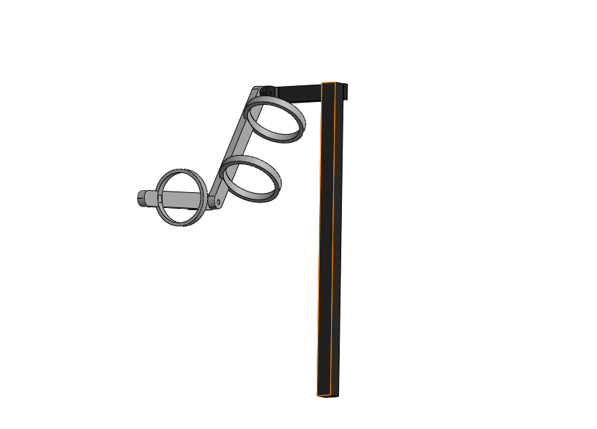

The modified design for review II

The control algorithm:

An impedance controller is chosen for the control of the exoskeleton after careful review of multiple papers. A normal proportional integral derivative controller controls the motion of the end effector in a stiff manner not considering the dynamic interaction with the surroundings. When the system interacts with an external object in a rather stiff way with sudden movements, a lot of damage can occur to the wearer of the exoskeleton arm. However, an impedance controller on the other hand controls the force acting in the end effector for a given input motion. The control of the ratio of force and motion gives a motion similar to the motion of the system in a viscous medium. The degree of stiffness in the response can be reduced easily from the control of impedance. This type of response improves the safety of the wearer when his exoskeleton arm comes in contact with the surrounding environment.

The control law for impedance control is as follows:

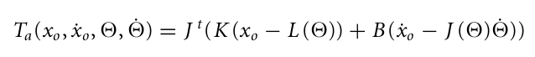

Where,

<math xmlns="http://www.w3.org/1998/Math/MathML"><mi>T</mi><mo>&#xA0;</mo><mi>i</mi><mi>s</mi><mo>&#xA0;</mo><mi>t</mi><mi>h</mi><mi>e</mi><mo>&#xA0;</mo><mi>a</mi><mi>c</mi><mi>t</mi><mi>u</mi><mi>a</mi><mi>t</mi><mi>o</mi><mi>r</mi><mo>&#xA0;</mo><mi>t</mi><mi>o</mi><mi>r</mi><mi>q</mi><mi>u</mi><mi>e</mi><mspace linebreak="newline"/><mi>L</mi><mfenced><mo>&#x2205;</mo></mfenced><mo>&#xA0;</mo><mi>i</mi><mi>s</mi><mo>&#xA0;</mo><mi>t</mi><mi>h</mi><mi>e</mi><mo>&#xA0;</mo><mi>f</mi><mi>o</mi><mi>r</mi><mi>w</mi><mi>a</mi><mi>r</mi><mi>d</mi><mo>&#xA0;</mo><mi>k</mi><mi>i</mi><mi>n</mi><mi>e</mi><mi>m</mi><mi>a</mi><mi>t</mi><mi>i</mi><mi>c</mi><mi>s</mi><mo>&#xA0;</mo><mi>f</mi><mi>u</mi><mi>n</mi><mi>c</mi><mi>t</mi><mi>i</mi><mi>o</mi><mi>n</mi><mspace linebreak="newline"/><mi>J</mi><mfenced><mo>&#x2205;</mo></mfenced><mo>&#xA0;</mo><mi>i</mi><mi>s</mi><mo>&#xA0;</mo><mi>t</mi><mi>h</mi><mi>e</mi><mo>&#xA0;</mo><mi>j</mi><mi>a</mi><mi>c</mi><mi>o</mi><mi>b</mi><mi>i</mi><mi>a</mi><mi>n</mi><mo>&#xA0;</mo><mi>o</mi><mi>f</mi><mo>&#xA0;</mo><mi>L</mi><mfenced><mo>&#x2205;</mo></mfenced><mspace linebreak="newline"/><mi>K</mi><mo>&#xA0;</mo><mi>i</mi><mi>s</mi><mo>&#xA0;</mo><mi>s</mi><mi>t</mi><mi>i</mi><mi>f</mi><mi>f</mi><mi>n</mi><mi>e</mi><mi>s</mi><mi>s</mi><mo>&#xA0;</mo><mi>v</mi><mi>e</mi><mi>c</mi><mi>t</mi><mi>o</mi><mi>r</mi><mspace linebreak="newline"/><mi>B</mi><mo>&#xA0;</mo><mi>i</mi><mi>s</mi><mo>&#xA0;</mo><mi>d</mi><mi>a</mi><mi>m</mi><mi>p</mi><mi>i</mi><mi>n</mi><mi>g</mi><mo>&#xA0;</mo><mi>v</mi><mi>e</mi><mi>c</mi><mi>t</mi><mi>o</mi><mi>r</mi><mspace linebreak="newline"/><mo>&#x2205;</mo><mo>&#xA0;</mo><mi>i</mi><mi>s</mi><mo>&#xA0;</mo><mi>t</mi><mi>h</mi><mi>e</mi><mo>&#xA0;</mo><mi>a</mi><mi>n</mi><mi>g</mi><mi>l</mi><mi>e</mi><mo>&#xA0;</mo><mi>v</mi><mi>e</mi><mi>c</mi><mi>t</mi><mi>o</mi><mi>r</mi><mspace linebreak="newline"/><mi>x</mi><mo>&#xA0;</mo><mi>i</mi><mi>s</mi><mo>&#xA0;</mo><mi>t</mi><mi>h</mi><mi>e</mi><mo>&#xA0;</mo><mi>p</mi><mi>o</mi><mi>s</mi><mi>i</mi><mi>t</mi><mi>i</mi><mi>o</mi><mi>n</mi><mo>&#xA0;</mo><mi>v</mi><mi>e</mi><mi>c</mi><mi>t</mi><mi>o</mi><mi>r</mi><mo>&#xA0;</mo><mi>o</mi><mi>f</mi><mo>&#xA0;</mo><mi>t</mi><mi>h</mi><mi>e</mi><mo>&#xA0;</mo><mi>e</mi><mi>n</mi><mi>d</mi><mo>&#xA0;</mo><mi>e</mi><mi>f</mi><mi>f</mi><mi>e</mi><mi>c</mi><mi>t</mi><mi>o</mi><mi>r</mi><mspace linebreak="newline"/><msub><mi>x</mi><mi>o</mi></msub><mo>&#xA0;</mo><mi>i</mi><mi>s</mi><mo>&#xA0;</mo><mi>t</mi><mi>h</mi><mi>e</mi><mo>&#xA0;</mo><mi>t</mi><mi>a</mi><mi>r</mi><mi>g</mi><mi>e</mi><mi>t</mi><mo>&#xA0;</mo><mi>p</mi><mi>o</mi><mi>s</mi><mi>i</mi><mi>t</mi><mi>i</mi><mi>o</mi><mi>n</mi><mo>&#xA0;</mo><mi>v</mi><mi>e</mi><mi>c</mi><mi>t</mi><mi>o</mi><mi>r</mi></math>

The modelling and control equations are simulated in MATLAB software. The kinematics of a 2 degree of freedom model is found from the 4 degree of freedom model calculated in the first section. The position output from the kinematics model and the target position is given as input to the control law.

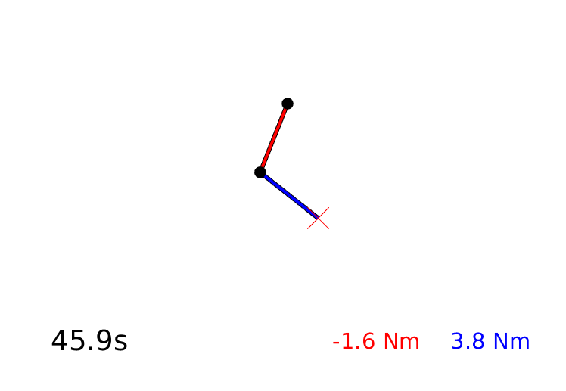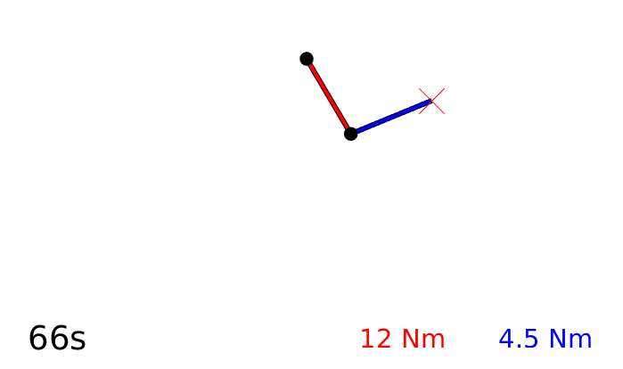

The above, is the simulation that was designed in the MATLAB environment. A 2 DOF exoskeleton arm is designed with the red link as upper arm and blue link as lower arm. The red ‘X’ marks the reference coordinate. On changing the reference coordinate in the simulation, the arm end effector moves towards the reference based on the control law.

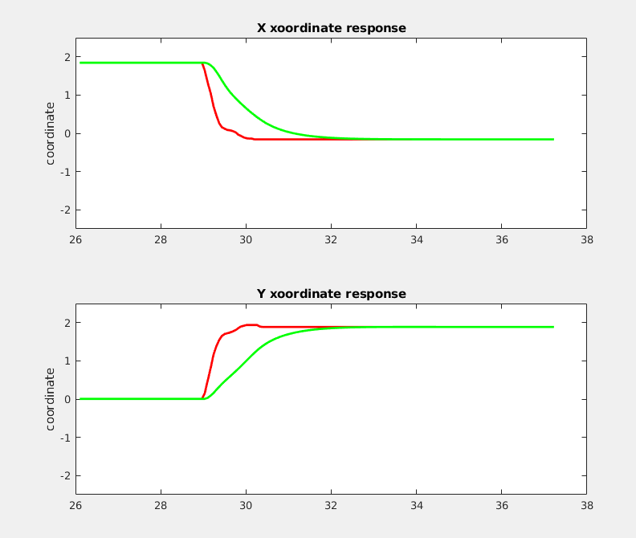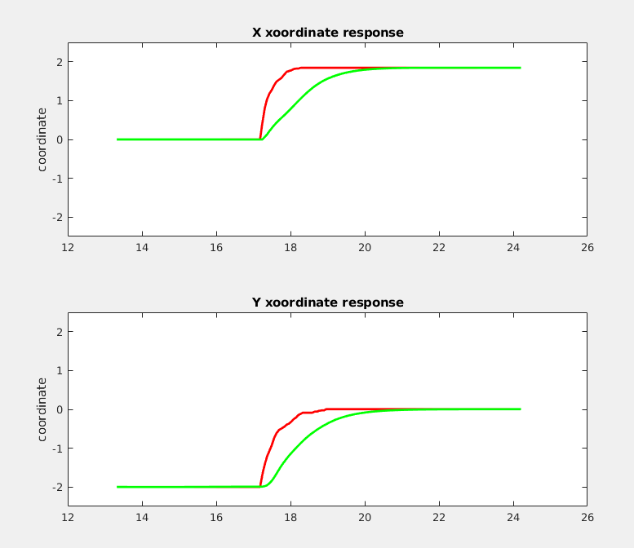

Figure A Figure B

RED - reference coordinate

GREEN - response coordinate

The above graphs are the response of the exoskeleton system to an impedance controller. The red line is the reference coordinate and the green line is the response of the system to the impedance controller. From the graph, it can be observed that the steady state error is insignificant and the settling time is less than 2 seconds.

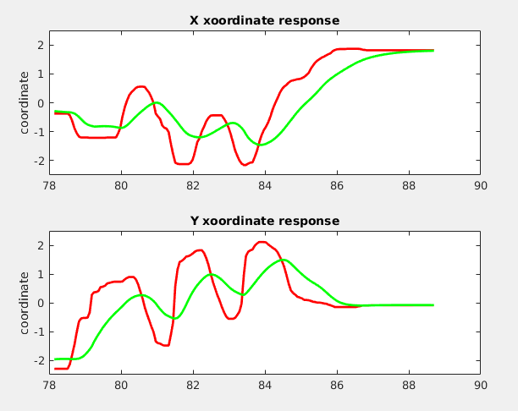

Response for a random coordinate trajectory

**Work to be done:**

1. Building the arm with the CAD files using gazebo physics engine

2. Integrating the impedance control algorithm in gazebo

3. Testing of the exoskeleton arm in gazebo simulation environment

**References:**

[1] Gull, Muhammad A.; Bai, Shaoping; Bak, Thomas. 2020. "A Review on Design of Upper Limb Exoskeletons." *Robotics* 9, no. 1: 16

[2] N. Hogan, "Impedance Control: An Approach to Manipulation," *1984 American Control Conference*, San Diego, CA, USA, 1984, pp. 304-313, doi: 10.23919/ACC.1984.4788393.

[3] J. Garrido, W. Yu and A. Soria, "Modular design and modeling of an upper limb exoskeleton," *5th IEEE RAS/EMBS International Conference on Biomedical Robotics and Biomechatronics*, Sao Paulo, 2014, pp. 508-513, doi: 10.1109/BIOROB.2014.6913828.

[4] Glowinski, Sebastian & Krzyzynski, Tomasz & Pecolt, Sebastian & Igor, Maciejewski. (2015). Design of motion trajectory of an arm exoskeleton. Archive of Applied Mechanics. 85. 75-87. 10.1007/s00419-014-0900-8.

[5] T. Prasertsakul, T. Sookjit and W. Charoensuk, "Design of exoskeleton arm for enhancing human limb movement," *2011 IEEE International Conference on Robotics and Biomimetics*, Karon Beach, Phuket, 2011, pp. 2199-2203.

[6] Bogue R. Exoskeletons and robotic prosthetics: a review of recent developments. Industrial Robot, Vol. 36, Issue 5, 2009, p. 421-427